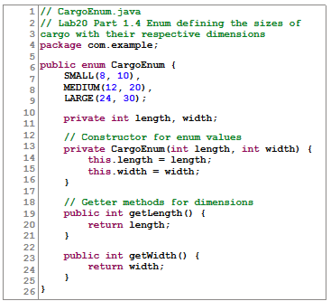

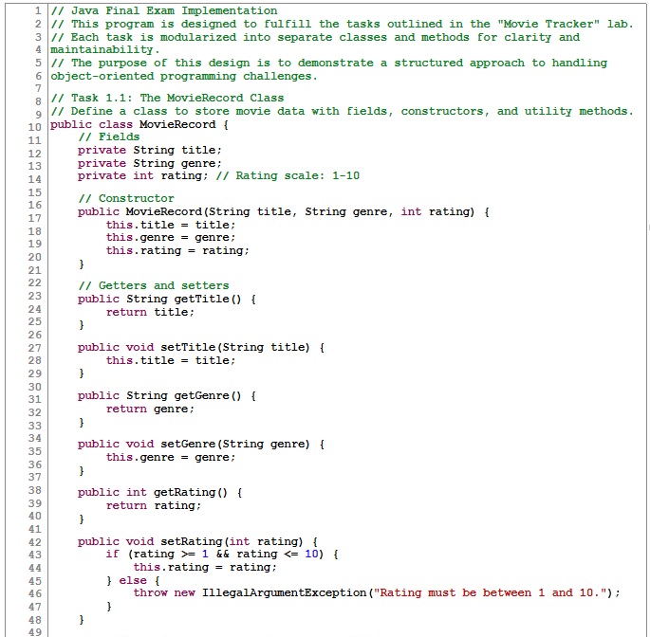

**BUILDER PATTERNS**

**BUILDER PATTERNS**

**BUILDER PATTERNS**

**Quiz 2**

1. True or false: A Scanner object should use System.out to get keyboard input.  
   **Correct answer:** False
2. A black text on a white background

   Description automatically generatedWhat does the following code print?

**Correct answer:** Goodbye

1. What character string do you use to force a new line (carriage return) to be printed?  
   **Correct answer:** \n
2. The statement ((5 < 10) || (10 < 5)) evaluates to:  
   **Correct answer:** True
3. What’s the best way to describe the job of the Scanner class?  
   **Correct answer:** It provides methods that enable your program to use keyboard or file
4. True or false: For data stored in a file, only commas can be used to separate the data.  
   **Correct answer:** False
5. What code prints "gopher" and the int variable i on the same line with two tab characters between them and a new line (carriage return)?  
   **Correct answer:** System.out.print("gopher\t\t" + i + "\n");
6. Which is the format code for an int in a printf() statement?  
   **Correct answer:** %d
7. Given the following:  
   String s = "gopher,27.0,Bob";  
   What line of code will separate the three values into a String array?  
   **Correct answer:** String[] data = s.split(",");
8. Given the statement:  
   double x = 42.579;  
   The Java statement that prints x with one decimal place in an 8-space-wide field, left justified is System.out.printf("%<What goes here?>\n", x); with what filled in for <What goes here?>?  
   **Correct answer:** -8.1f

**Quiz 3**

1. True or false: Declaring the data in a class “private” makes it safe from hackers.  
   **Correct answer:** False
2. How is a Java object created?  
   **Correct answer:** Call one of its class’ constructors
3. A close-up of a computer code

   Description automatically generatedWhen is the new operator used?  
   **Correct answer:** To create an object on the heap
4. What error does the following code have?

**Correct answer:** The array is not instantiated.

1. What will the following code display?

**Correct answer:** 5 4 3

1. When should you choose a for loop over a while loop?  
   **Correct answer:** It’s just a matter of style, choose either one.
2. Which of these defines the OO concept “class”?  
   **Correct answer:** All of these are correct.
3. Suppose that a String array named x has been correctly initialized and filled with 5 Strings. Which of the following will not display x’s contents?  
   **Correct answer:** int i=0; while (++i<5) { System.out.println(x[i]); }
4. What is an overloaded constructor?  
   **Correct answer:** A constructor method that has at least one parameters
5. What will the following code display?

**Correct answer:** 0 5

**Quiz 4**

1. What is the job of a setter method?  
   **Correct answer:** To set an object’s member item’s value
2. True or False: All method parameters of class types are pass-by-value.  
   **Correct answer:** True
3. Suppose that a library application will model books contained in the library’s catalog. What association should there be between class Catalog and class Book?  
   **Correct answer:** Aggregation
4. In an association relationship between two classes:  
   **Correct answer:** First class has a method that takes a parameter of the second class
5. True or False: All method parameters of primitive types are pass-by-value.  
   **Correct answer:** True
6. True or False: The Java compiler requires that every recursive function has a stopping condition.  
   **Correct answer:** False
7. A static method...  
   **Correct answer:** Can use static member data
8. In OO programming, a composition relationship between two classes:  
   **Correct answer:** Makes one class the “part” and the other one the “whole”
9. What is a static method?  
   **Correct answer:** A method that is shared by all objects of a class
10. Suppose this method already exists:

public void moveRobot()  
Which of the following is an overload of moveRobot()?  
**Correct answer:** public void moveRobot(int steps)

**Quiz 5**

1. Suppose class Child inherits from class Parent. After the statement Parent x = new Child(), what does x instanceof Child evaluate as?  
   **Correct answer:** True
2. The value of a public static variable can only be changed by classes in the same package.  
   **Correct answer:** False
3. Which of the following is true for an inheritance hierarchy?  
   **Correct answer:** Upcasting is always safe
4. What is used to prevent side effects in a class?  
   **Correct answer:** Making a copy of any by-reference data in a setter or getter
5. A final method cannot be overridden.  
   **Correct answer:** True
6. What is the purpose of the keyword protected?  
   **Correct answer:** It makes parent data available to its child in inheritance
7. What is true about the Comparable interface?  
   **Correct answer:** You only get one implementation of compareTo()
8. What is the purpose of the category “package private”?  
   **Correct answer:** It makes data available to other classes in the same package
9. Why would you want several classes that implement Comparator<YourClass>?  
   **Correct answer:** To sort collections on different fields of YourClass
10. True or false: A final class cannot have children.  
    **Correct answer:** True

**Quiz 6**

1. What does the finally block do?  
   **Correct answer:** It executes whether there was an exception or not
2. How does the Factory Method pattern keep the client class from creating its own version of the classes in the Factory?  
   **Correct answer:** It makes the constructors private or package private
3. What is the point of the Singleton pattern?  
   **Correct answer:** It only allows one instance of a class to be constructed
4. If the code doesn’t put a try block around a method that throws a Checked Exception, what happens?  
   **Correct answer:** Compiler will warn you: use try-catch or have the enclosing method throw
5. Both an Adapter and a Proxy sit between a client and a server. What’s the difference between the two?  
   **Correct answer:** A Proxy keeps the same method signature; an Adapter changes it
6. How does the Factory Method Pattern decrease coupling?  
   **Correct answer:** The client doesn’t know how objects are created
7. What is the point of the Builder pattern?  
   **Correct answer:** It makes it easier to construct objects with many data members
8. Why don’t you normally use a try-catch block for an Error exception?  
   **Correct answer:** Even if you catch one, there’s usually no solution to the problem
9. Which kind of Exception must you have a try-catch block for (or tag the method)?  
   **Correct answer:** Checked
10. Why might you write a custom exception class?  
    **Correct answer:** To provide new ways to catch application-specific errors

**Quiz 7**

1. How is priority assigned for a PriorityQueue?  
   **Correct answer:** Depends on Comparable or Comparator
2. True or false: It’s more efficient to binary search a TreeMap’s entrySet() than to use get().  
   **Correct answer:** False
3. What does “collision” mean for Maps?  
   **Correct answer:** Two objects hash to the same position
4. Why are data collisions an important issue for Maps?  
   **Correct answer:** A different position must be found for the data item that collided with the first one
5. What is the term for the type of behavior a Queue provides?  
   **Correct answer:** First in, first out

**Quiz 8**

1. What operation(s) enables a program to read or write data to an arbitrary place in a binary file?  
   **Correct answer:** seek()
2. How do you enhance the functionality of a given Java I/O class?  
   **Correct answer:** Wrap the given stream inside something more useful
3. In order to read or write an object using an object stream, what interface must its class implement?  
   **Correct answer:** Serializable
4. What is the difference between byte streams and character streams?  
   **Correct answer:** The first reads a single byte at a time, the second reads two bytes at a time
5. Which Java I/O classes should be used to read and write Unicode?  
   **Correct answer:** Character streams
6. What method in Files gives a file a new name?  
   **Correct answer:** move()
7. Theoretically, which should be faster?  
   **Correct answer:** Buffered I/O
8. True or false: To do formatted writing to a file, the best thing to use is a PrintWriter.  
   **Correct answer:** True
9. True or false: An object stream reads and writes one or more objects at a time.  
   **Correct answer:** True
10. True or false: The only use for the Scanner class is to wrap System.in.  
    **Correct answer:** False

**Briefing Doc: Java I/O, Reflection, Generics, Networking, and Multithreading**

This briefing document summarizes key concepts and facts from five provided sources covering various Java topics: input/output (I/O), reflection, generics, networking, and multithreading.

**1. Java I/O**

* **Types of streams:** Java I/O utilizes various stream types, including byte streams (single bytes), character streams (Unicode characters), and random access files (binary records).
* **Buffered vs. unbuffered streams:** Buffered streams enhance performance by reading/writing larger data chunks, reducing OS interaction. Unbuffered streams handle requests directly with the OS, resulting in slower operations.
* **Important classes:** BufferedReader, BufferedWriter, Scanner, and PrintWriter simplify file reading, writing, and parsing.
* **Binary files:** Objects can be stored directly using ObjectInputStream and ObjectOutputStream, requiring the class to implement the Serializable interface. RandomAccessFile enables direct byte-level access, ideal for homogeneous data records.
* **File utilities:** The File, Path, Files, and Paths classes provide methods for manipulating files and directories, such as creating, deleting, moving, and reading their contents.

**2. Reflection and RTTI**

* **Reflection:** Compile-time analysis of a class's structure using Class.forName(), allowing access to information like its name, interfaces, and methods.
* **Runtime Type Information (RTTI):** Dynamically obtaining information about a class at runtime, even those downloaded as .class files. This allows inspection of fields, constructors, and methods, and even invoking methods on dynamically created objects.

**3. Generics**

* **Purpose:** Generics enhance code reusability by using placeholders (like T) for types, filled in later with actual classes.
* **Advantages:** Avoids typecasting associated with using Object type and supports multiple type parameters (e.g., Map<String, ArrayList<Movie>>).
* **Potential Issues:** Generics require careful consideration of the methods used on generic types and may need to be restricted using extends to ensure specific functionalities.
* **Wildcards:** <? extends SomeClass> enables flexibility by allowing subtypes of a class to be used within generics, overcoming limitations of direct inheritance relationships in generic types.

**4. Networking**

* **Concepts:** Networking involves concepts like DNS addresses, URLs, sockets, and ports.
* **Client-Server Model:** Clients connect to servers for services, involving a connection request, message exchange, and optional reply.
* **Socket programming:** The Socket and ServerSocket classes enable communication over networks using specific ports. Servers listen for connections, clients initiate them.
* **Remote Method Invocation (RMI):** An object-oriented version of Remote Procedure Call (RPC) that hides communication details and allows remote method execution using interfaces extending Remote and classes implementing them.

**5. Multithreading**

* **Concepts:** Threads are independent units of execution within a process, sharing program state but having their own program counters and local state.
* **Benefits:** Enables concurrent or parallel execution, potentially improving performance by utilizing multiple cores or separating concerns (e.g., responsive UI while a network operation occurs).
* **Challenges:** Debugging complexity, potential data corruption through race conditions, and performance limitations due to sequential parts of the program.
* **Creating Threads:** Threads can be created using classes implementing Runnable or extending Thread, both requiring overriding the run() method.
* **Synchronization and Thread Safety:** Protecting shared data through techniques like synchronized methods, thread-safe data structures (ArrayBlockingQueue, ConcurrentHashMap), and explicit locks (ReentrantLock) prevents race conditions.
* **Thread Pools:** Efficiently manage threads using ExecutorService with cached or fixed thread pools, streamlining task execution.
* **Tasks and Futures:** Callable<T> tasks return results, managed by Future<T> objects, allowing asynchronous execution and result retrieval using get().

**Important Quotes:**

* **I/O:** "If you have the choice, use buffered character streams – faster, UTF-oriented."
* **RTTI:** "The difference is you can query that information at runtime instead of compile time – that is, dynamically – this is called Run Time Type Information (RTTI)."
* **Generics:** "The advantage of generic code is its reusability: you can substitute (almost) any class. Almost, because the methods you use on the generic must exist and make sense."
* **Networking:** "Think of the socket like a street address: your mail gets sent here. Then the port is like your apartment number: not all mail sent to this street address belongs to you; you should only receive the stuff with your apartment number on it."
* **Multithreading:** "Race condition: when shared data can become inconsistent (corrupted) due to updates from multiple threads."

This document provides a high-level overview of the provided information. For a deeper understanding, refer to the original source materials.

**Java Programming Concepts: A Briefing Document**

This document provides a comprehensive overview of key Java programming concepts, drawing insights and examples from various lecture materials. The document covers data types, object-oriented principles (encapsulation, inheritance, polymorphism), exception handling, collections, regular expressions, input/output operations, multithreading, and networking.

**I. Foundations**

* **Data Types:** Java is a strongly typed language, requiring variable declarations with specific data types. This ensures type consistency and facilitates compile-time error detection.
* **Primitive types** include boolean, char, byte, short, int, long, float, and double. These types have predefined sizes and value ranges, catering to different data representation needs.
* **Class types** are user-defined data structures that encapsulate data and behavior.
* **Strings:** Strings are immutable objects representing sequences of characters.
* Key operations include toUpperCase(), toLowerCase(), trim(), equals(), equalsIgnoreCase(), compareTo(), and split().
* Importantly, strings should be compared using .equals() rather than ==, as the latter compares object references, not character content.
* **Memory Management:** Java employs a garbage collector to reclaim unused memory occupied by objects on the heap. This automatic memory management simplifies development and reduces memory leak risks.

**II. Object-Oriented Programming**

* **Encapsulation:** This principle promotes data hiding and controlled access through getter and setter methods.
* Access control mechanisms (public, protected, package-private, private) define the visibility and accessibility of data and methods from different parts of the code.
* Encapsulation enhances code maintainability, security, and testability by limiting direct manipulation of internal object state.
* Quote: *"Controlling what gets set: don’t copy references ... This assumes a copy constructor exists"* emphasizes the importance of avoiding direct reference copying to maintain encapsulation.
* **Inheritance:** Classes can inherit properties and behaviors from parent classes using the extends keyword.
* Inheritance promotes code reuse, reduces redundancy, and establishes "is-a" relationships between classes.
* Quote: *"Constructors are inherited, but use super() at the beginning of the constructor"* clarifies constructor inheritance and the role of super() in invoking the parent constructor.
* **Polymorphism:** This concept allows objects of different classes to be treated as objects of a common type.
* Interfaces, defined using the interface keyword, specify a set of methods that implementing classes must provide.
* Quote: *"The interface and method are generic, so substitute your class name for T"* highlights the use of generics in interface definitions.
* Polymorphism enables flexible and extensible code by allowing for different implementations of the same method signature.

**III. Advanced Concepts**

* **Exception Handling:** Exceptions represent exceptional events or errors during program execution.
* Java provides a mechanism for handling exceptions using try-catch blocks.
* Quote: *"If there's some task that needs to be done whether an Exception is caught or not, put it in the finally clause"* explains the role of the finally block in ensuring cleanup operations.
* Exception handling enhances program robustness and fault tolerance by providing a structured way to manage errors.
* **Collections:** Collections are data structures that store and organize groups of objects.
* Key interfaces include List, Set, Queue, and Map, each offering distinct characteristics and methods for data manipulation.
* Quote: *"remove() on a queue is un-queue-like"* points out potential pitfalls when using methods that deviate from a data structure's intended behavior.
* Collections facilitate efficient data management and processing for various programming tasks.
* **Regular Expressions:** These are powerful tools for pattern matching and text manipulation.
* Java provides the Pattern and Matcher classes for working with regular expressions.
* Quote: *"To use regular expressions in Java, import java.util.regex.*"* instructs on importing the necessary library for regular expression support.
* Regular expressions simplify complex text processing tasks, including validation, search, and extraction.
* **Input/Output Operations:** Java offers various classes for interacting with files and streams.
* BufferedReader, BufferedWriter, Scanner, DataInputStream, and DataOutputStream are some of the commonly used classes for reading and writing data.
* Quote: *"The Scanner class is not part of the I/O library (it's in java.util), but it can be used to wrap other classes for parsing out data from a buffered stream"* clarifies the role of Scanner in data parsing.
* Understanding input/output operations is crucial for handling file interactions and data persistence.
* **Multithreading:** Multithreading enables concurrent execution of multiple threads within a program.
* The Thread and Runnable interfaces facilitate thread creation and management.
* Quote: *"Threads can share memory, or not, depending on your design"* emphasizes the design considerations related to memory sharing among threads.
* Multithreading enhances program performance by parallelizing tasks and utilizing multiple processor cores.
* Synchronization mechanisms, such as synchronized methods and locks, are crucial for preventing race conditions and ensuring data integrity in multithreaded environments.
* **Networking:** The Socket and ServerSocket classes provide the foundation for network communication in Java.
* Servers listen for client connections on specific ports, while clients initiate connections to servers.
* Quote: *"Port stepper: code that tries to connect using a port; if it fails, increments to the next port and tries again"* describes a common strategy for handling port availability.
* Networking concepts are essential for building distributed applications and interacting with remote resources.

**IV. Conclusion**

This briefing document highlights the fundamental and advanced concepts in Java programming. Mastery of these concepts is essential for developing robust, efficient, and scalable applications. By understanding data types, object-oriented principles, exception handling, collections, regular expressions, input/output operations, multithreading, and networking, programmers can effectively leverage the power and flexibility of the Java language.

